DECIMALS
Introduction to Decimals
Numbers with a point are decimal numbers. For e.g. weight, height and interest rate in the following examples.
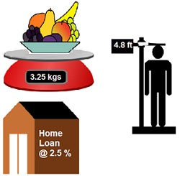
Decimals represent fractions. For e.g. In the following figure, One block divided into 10 equal parts. In fractional terms, each part is 1/10 (one-tenth) of a unit. It can be written as 0.1 in decimal notation.

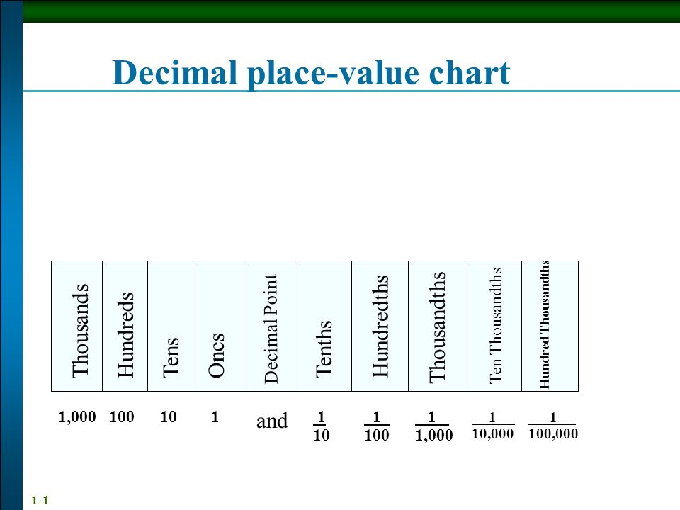

Example:
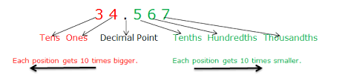
Examples:
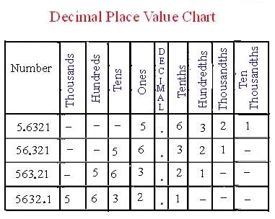
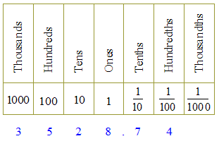

Question 1: Write the place value of 2 in the following decimal numbers:
- 2.56
Answer: One
- 21.37
Answer: Ten
- 10.25
Answer: One tenth
- 9.42
Answer: One hundredth
- 63.352
Answer: One thousandth

